SQL Hackathon
--33.Calculate the average gestational age at delivery for GDM vs non-GDM pregnancies
QUERY and Output:
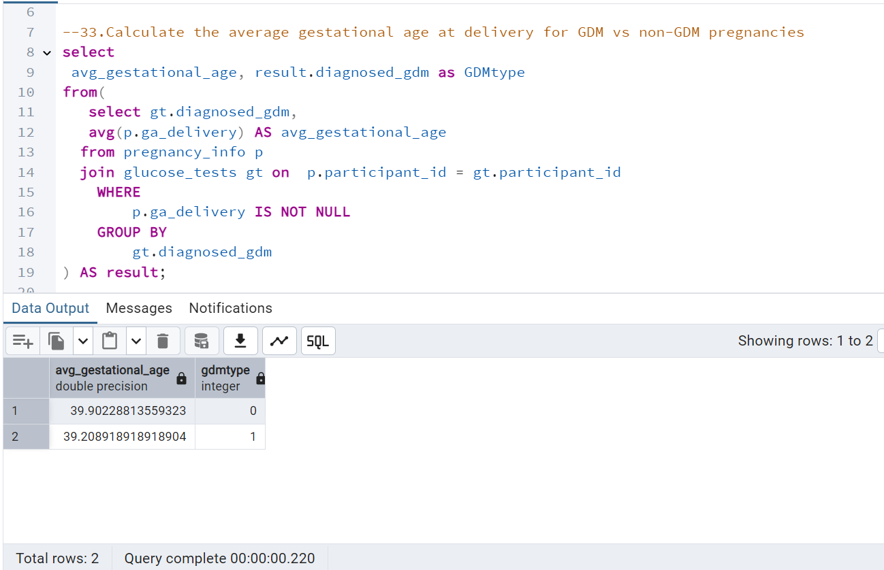

--Q34.Calculate the Participants Mean arterial Pressure (MAP) for both Visit 1 and Visit 3.
Query and OUTPUT
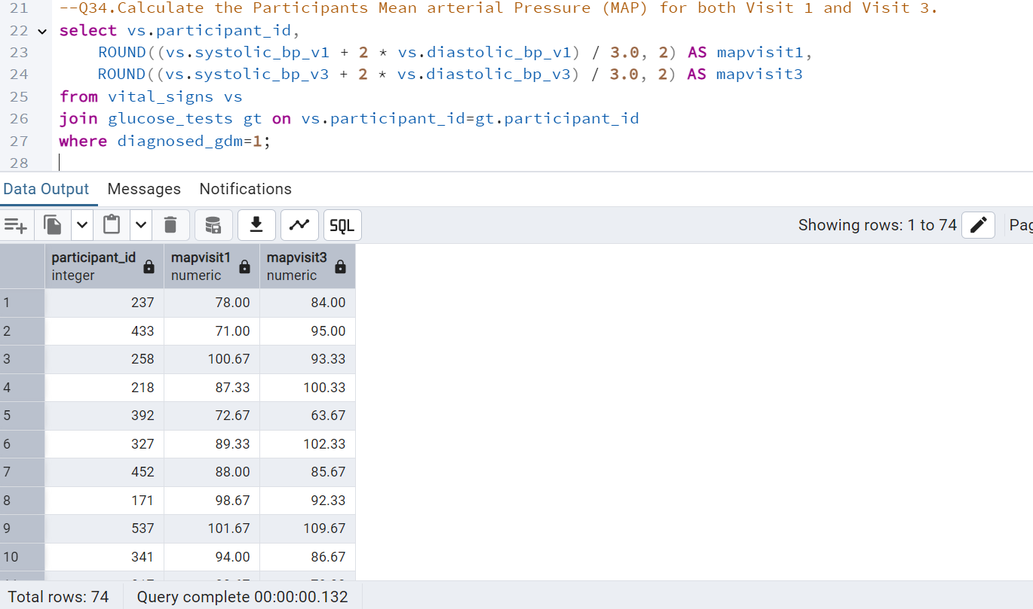

--35.List pregnancies that exceeded the standard 40 weeks full term and calculate the number of days delayed.
Query and OUTPUT
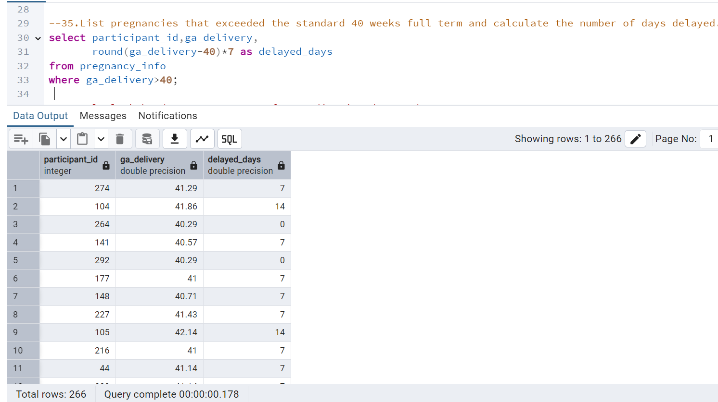

--36.Apply lookahead concept to transform medication data and
new column in the glucose_tests table.
Ouery and output:
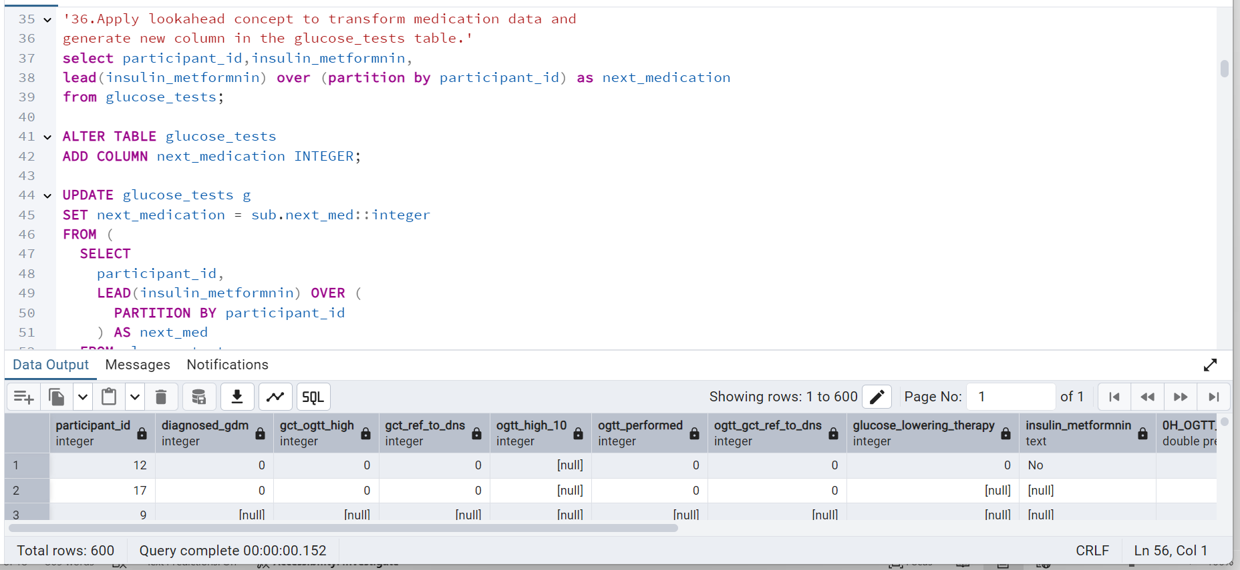

--37.Find the correlation between Vitamin D levels and GDM diagnosis
Query and OUTPUT:
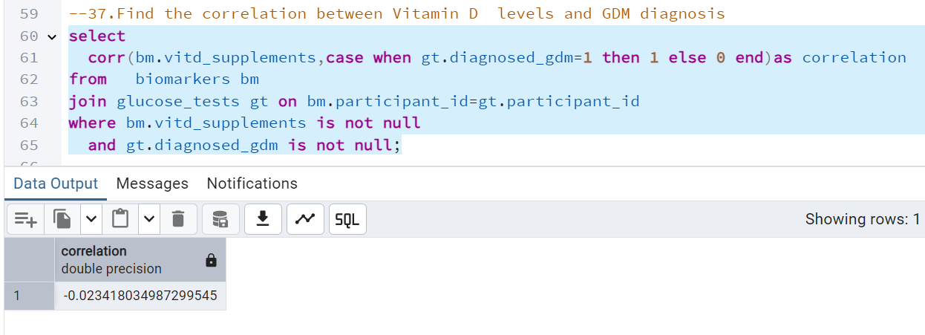

38.Calculate the Cumulative percentage of Insulin medication consumption for gestational diabetic patients.
Query and OUTPUT:
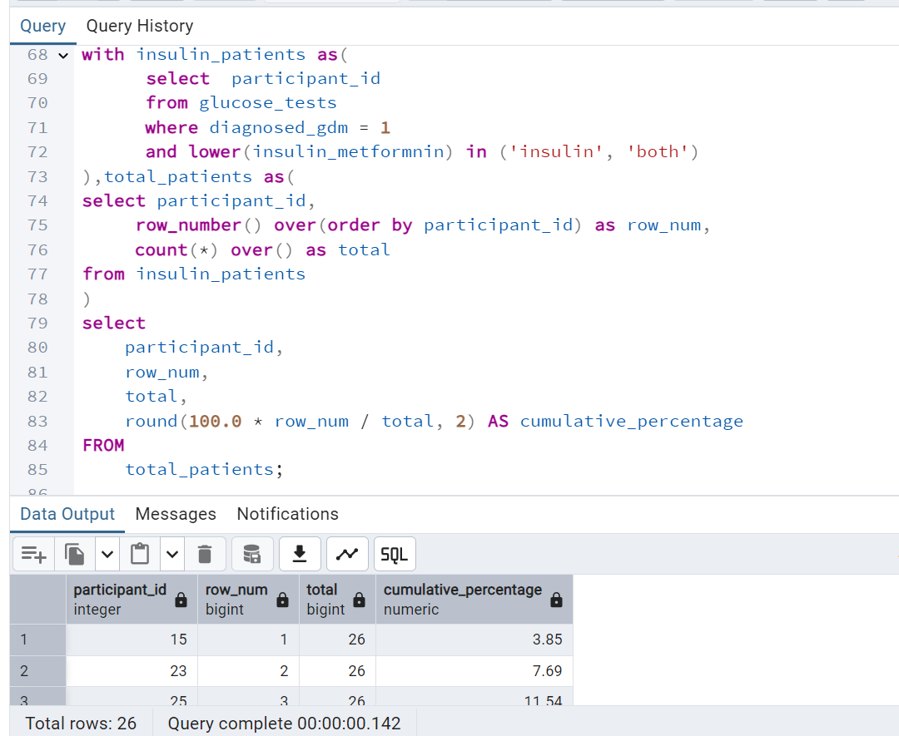

39.Count the Patient based on "BMI" category using "Width_bucket" function
Query and Output
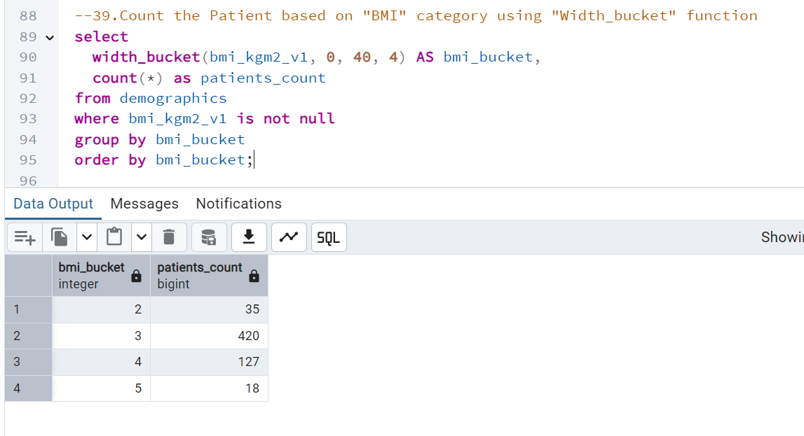
40.Transform the values of edd_estimation_method to replace the abbreviations and handle nulls.

Query and output:
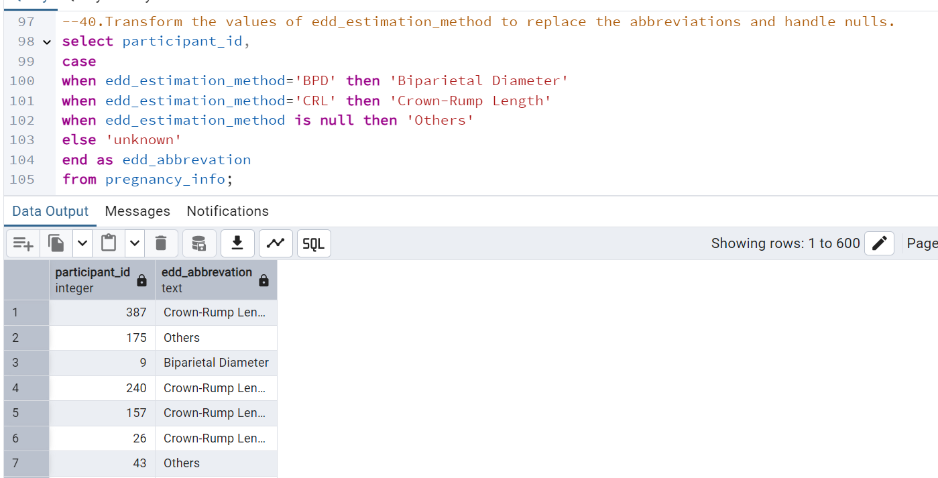

41.Analyze the impact of GDM on infant outcomes using a composite score
Query and Output
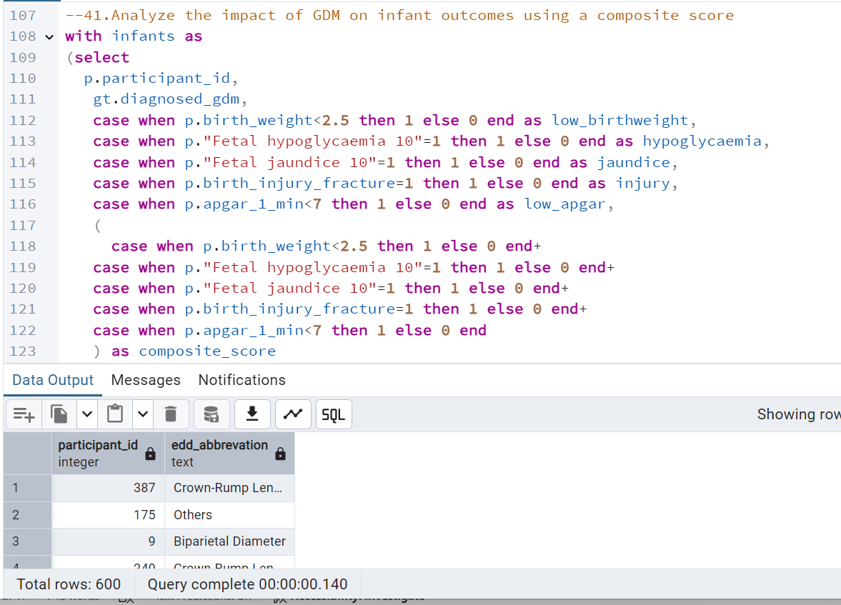
42.Retrieve a list of participants who share the same estimated delivery due date with at least one other participant
Query and output:
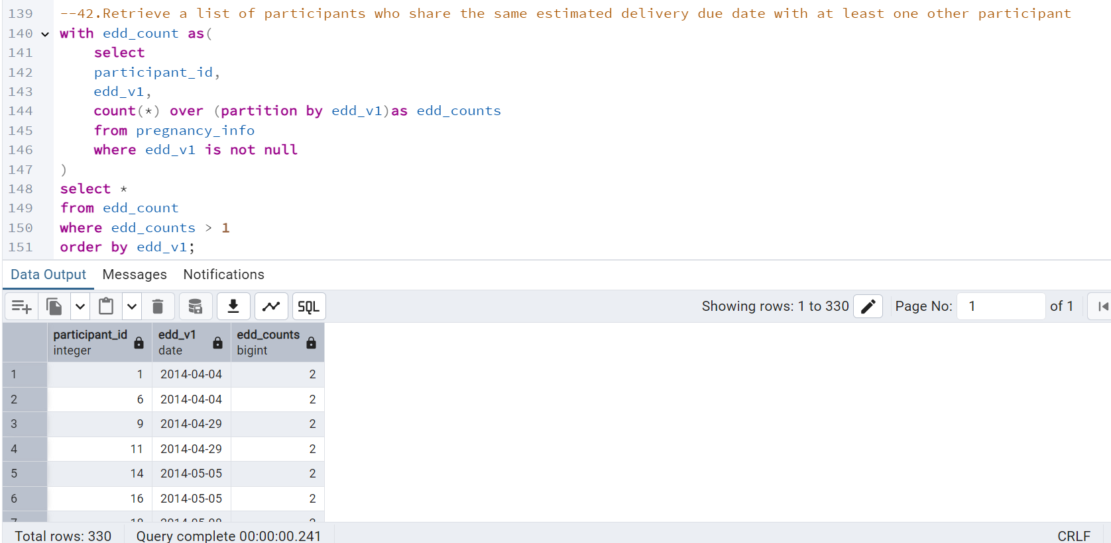
43.Of all miscarriages records what percentage were currently using tobacco or drinking and what % were not?
Query and output:
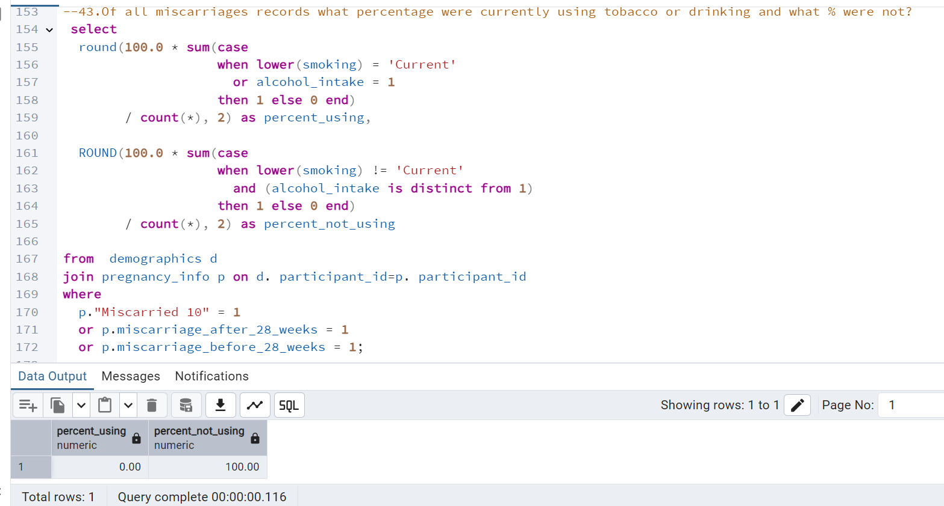
44.Using window functions, identify all participants whose pulsation significantly considered an outlier.
Hint: Threshold greater than 20 bpm
OUTPUT
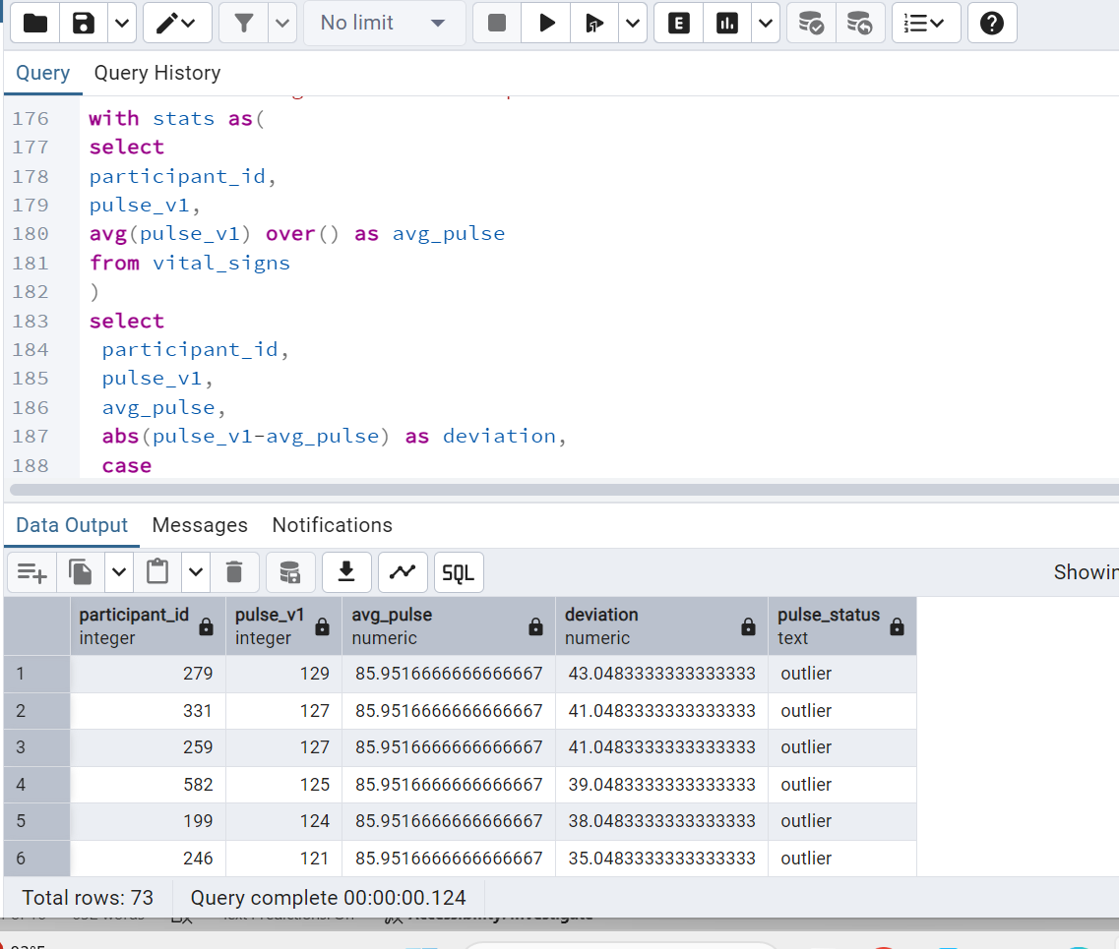

45.Display the participant_id from 100 to 200 without using where condition.
Query and Output;
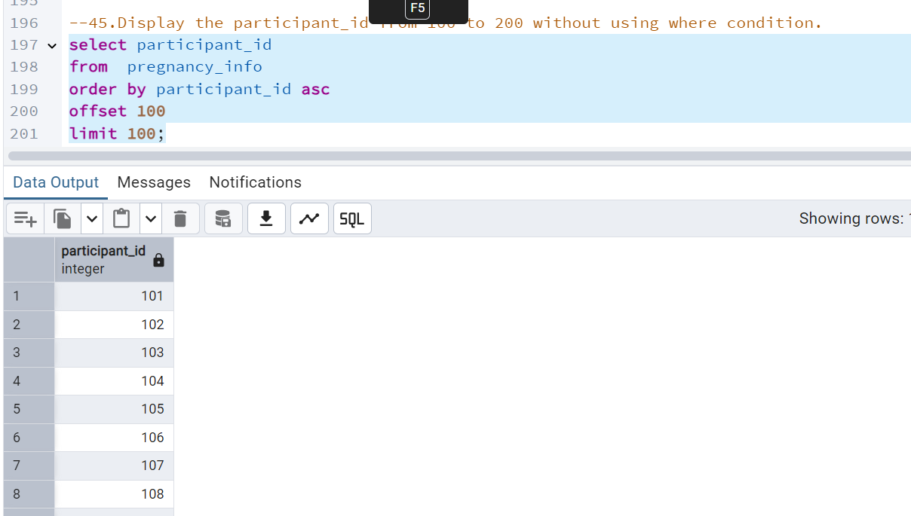
46.Create a Backup table by using existing demographics table.List the differences observed between backup table and Base table
Query and Output:
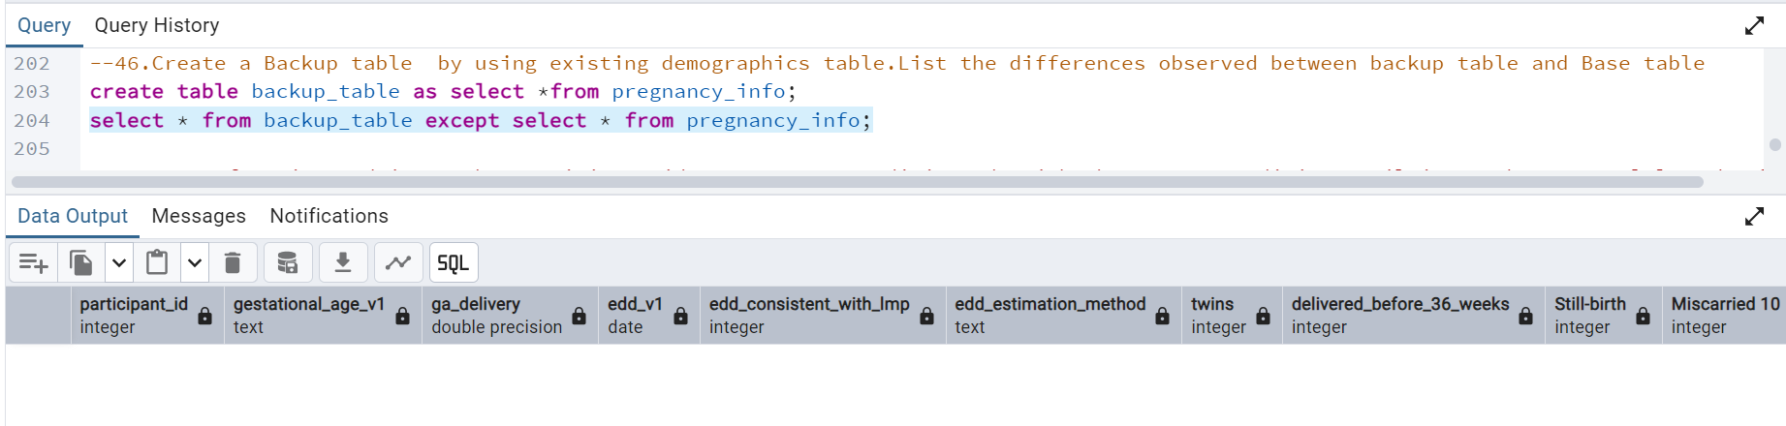
Differences:
- Backup table did not have the constraints like primary and foreign key
- Backup table did not have triggers

47.Create function and input the participant id, generate a 16-digit code with characters or digits until it reaches a total length of 16. Also, display the number of characters added during this process.
Query and Output:
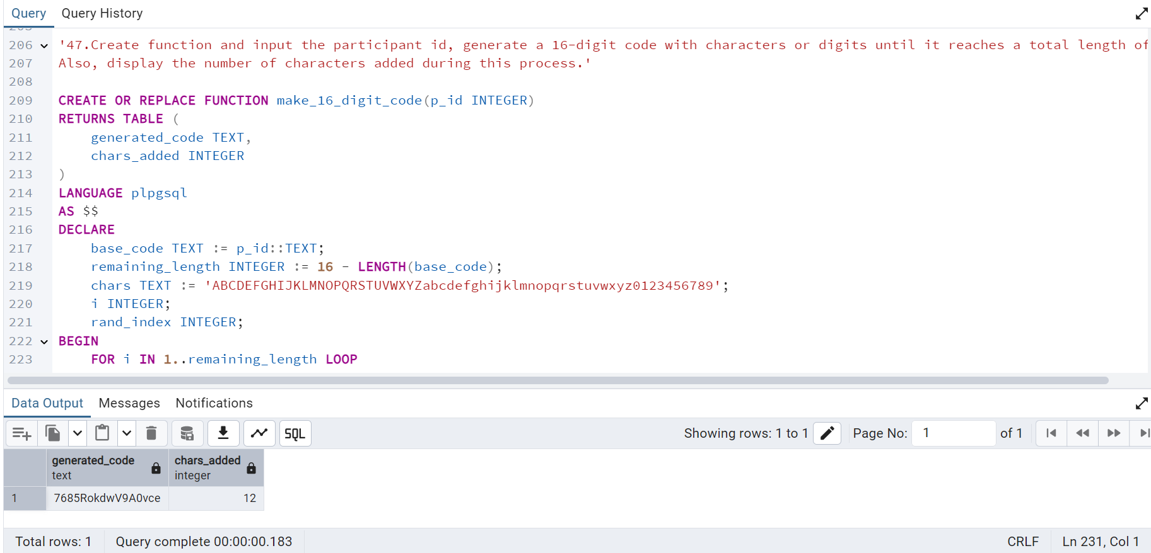
48.Display the last inserted row in demographics table without using limit.
Query and output:
